CHAPTER - 1
INTRODUCTION

1.1 OVERVIEW:
Online Banking is all about knowing our customer need and provide them with the right service at the right time through right channel 24*7 day a week.
Being “electronic”, it not only provides its customers with faster and better facilities, it even reduces the manual overhead of accounts maintenance.
1.2 ABOUT THE PROJECT:
This project is aimed at developing an Online Banking for customer. The system is an online application that can be accessed throughout the organization and outside as well with proper login provided.
The project has been planned to be having the view of distributed architecture, with centralized storage of the database. The application for the storage of the data has been planned. Using the constructs of MYSQL Server and all the user interfaces have been designed using the JAVA and JSP. The database connectivity is planned using the “Database” methodology. The standards of security and data protective mechanism have been given a big choice for proper usage. The application takes care of different modules and their associated reports, which are produced as per the applicable strategies and standards that are put forwarded by the administrative staff.
The entire project has been developed keeping in view of the distributed client server computing technology, in mind. The user interfaces are browser specific to give distributed accessibility for the overall system. The internal database has been selected as MYSQL Server. The basic constructs of table spaces, clusters and indexes have been exploited to provide higher consistency and reliability for the data storage. The MYSQL Server was a choice as it provides the constructs of high-level reliability and security. The total front end was dominated using the HTML 5. At all proper levels high care was taken to check that the system manages the data consistency with proper business rules or validations. The database connectivity was planned using the latest “Database connection” technology provided by MYSQL. The authentication and authorization was crosschecked at all the relevant stages.

1.3 PURPOSE:
The Online Banking suite provides a global accounting foundation that provides the all private banks with electronic banking facilities. It allows client of private banks to carry out their day to day banking transactions.
1.4 SCOPE:
The Online Banking project is widely applicable with private banks. It can even be used in industries for their personal transactions (working).
1.5 FUNCTIONAL COMPONENTS OF THE PROJECT:
Following are the functional needs of the software:-
1. Customer must have a valid user ID and password to login to the system.
2. After the valid user logs in, the system shows the present balance in that particular account number.
3. Customer can perform transactions like Transfer Money and Withdrawal from his account.
4. Proper help to be provided as and when requested by the customer.
1.6 MORE FUNCTIONALITY CAN BE ADDED TO “ENHANCE THE PROJECT”:
1. By adding new modules of different accounts like saving A/C, current A/C etc. to facilitate new customers/users.
2. By the use of electronic media, “Digital Signature” on the card can be provided with the customer to make it secure and efficient.

CHAPTER - 2
SYSTEM ANALYSIS

2.1 EXISTING SYSTEM:
The Existing system is a not computerized system which is maintained at individual databases i.e. in excel sheets and papers, it’s a time delay process. In the existing system the number of staff required for completing the work is more, while the new system requires lesser staffs generally.
The data entry process requires the data on the paper, which is then feed into the application by the operator while doing so; the data entry operator has to look into the paper again &again and thus the chances of in accuracies in the typed contents increases. Also the process includes higher transportation cost, increased handling cost, more time delays, low accuracy, more usage of resources like registers, books, papers, etc.

2.2 PROPOSED SYSTEM:
The Proposed System is a Computerized System but which is maintained at Centralized Database i.e. in Automated forms its very Fast Process. And maintaining all the records in online systems database which makes it very easy to access and retrieve data from the database. If they want search any details they can easily find out. It provides multiple user accessibility and also has different user privileges. So the system is accessible for all the custom of the bank.

2.3 BENEFITS OF THE SYSTEM:
- Quick and authenticated access to accounts via Desktop.
- Managing your money is easy and transfer money from one account to another.
- Online Banking gives you the flexibility to manage your money at any time, 24/7, 365 days a year.
- Improved information security and restricting unauthorized access.
- Minimize Storage Space.

CHAPTER - 3
FEASIBILITY REPORT

3.1 UNDERSTANDING FEASIBILITY:
Feasibility study means the analysis of problem to determine if it can be solved effectively. In other words it is the study of the possibilities of the proposed system it studies the work ability, impact on the organization ability to meet user’s need and efficient use of resources.
Three aspects in which the system has to be feasible are:-
3.1.1 ECONOMICAL FEASIBILITY:
The economical analysis checks for the high investment incurred on the system. It evaluates development &Implementing charges for the proposed “Banking Project”. The Software used for the development is easily available at minimal cost & the database applied is freely available hence it results in low cost implementation.
3.1.2 TECHNICAL FEASIBILITY:
This aspect concentrates on the concept of using Computer Meaning, “Mechanization” of human works. Thus the automated solution leads to the need for a technical feasibility study.
The focus on the platform used database management and users for that Software.
The proposed system doesn’t require an in depth technical knowledge as the system development is simple and easy to understand. The Software used makes the system user friendly (GUI). The result obtain should be true in the real time conditions.
3.1.3 BEHAVIOURAL FEASIBILITY:
Behavioral feasibility deals with the runtime performance of the Software, the proposed system must score higher than the present in the behavioral study. The Software should have end user in mind when the system is designed while designing Software the programmer should be aware of the conditions user’s Knowledge input, output, calculations etc.

CHAPTER - 4
SOFTWARE REQUIREMENT SPECIFICATIONS

4.1 HARDWARE REQUIREMENTS:
Processor : Intel Core i3 and above.
RAM : 2GB and above.
Hard disk : 250 GB and above.

4.2 SOFTWARE REQUIREMENTS:
Operating System : Any Graphical OS.
Language : JAVA, JSP & HTML.
Scripting : JavaScript.
Web Server : Apache Tomcat.
RDBMS/Back End : SQL-Server/Oracle.

4.3 JAVA TECHNOLOGY:
Java technology is both a programming language and a platform.

4.3.1 THE JAVA PROGRAMMING LANGUAGE:
The Java programming language is a high-level language that can be characterized by all of the following buzzwords:
- Simple
- Architecture neutral
- Object oriented
- Portable
- Distributed
- High performance
- Interpreted
- Multithreaded
- Robust
- Dynamic
- Secure
With most programming languages, you either compile or interpret a program so that you can run it on your computer. The Java programming language is unusual in that a program is both compiled and interpreted. With the compiler, first you translate a program into an intermediate language called Java byte codes —the platform-independent codes interpreted by the interpreter on the Java platform. The interpreter parses and runs each Java byte code instruction on the computer. Compilation happens just once; interpretation occurs each time the program is executed. The following figure illustrates how this works.

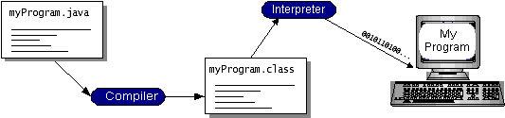
Figure 4.3.1.1- Working of Java
You can think of Java byte codes as the machine code instructions for the Java Virtual Machine (JVM). Every Java interpreter, whether it’s a development tool or a Web browser that can run applets, is an implementation of the JVM. Java byte codes help make “write once, run anywhere” possible. You can compile your program into byte codes on any platform that has a Java compiler. The byte codes can then be run on any implementation of the JVM. That means that as long as a computer has a JVM, the same program written in the Java programming language can run on Windows 2000, a Solaris workstation, or on an iMac.

4.3.2 THE JAVA PLATFORM:
A platform is the hardware or software environment in which a program runs. We’ve already mentioned some of the most popular platforms like Windows 2000, Linux, Solaris, and MacOS. Most platforms can be described as a combination of the operating system and hardware. The Java platform differs from most other platforms in that it’s a software-only platform that runs on top of other hardware-based platforms.
The Java platform has two components:
The Java Virtual Machine (JVM)
The Java Application Programming Interface (Java API)
You’ve already been introduced to the JVM. It’s the base for the Java platform and is ported onto various hardware-based platforms.
The Java API is a large collection of ready-made software components that provide many useful capabilities, such as graphical user interface (GUI) widgets. The Java API is grouped into libraries of related classes and interfaces; these libraries are known as packages.
The next section, What Can Java Technology Do?, highlights what functionality some of the packages in the Java API provide.
The following figure depicts a program that’s running on the Java platform. As the figure shows, the Java API and the virtual machine insulate the program from the hardware.
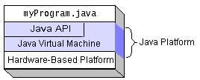
Figure 4.3.2.1- The Java Platform
Native code is code that after you compile it, the compiled code runs on a specific hardware platform. As a platform-independent environment, the Java platform can be a bit slower than native code. However, smart compilers, well-tuned interpreters, and just-in-time byte code compilers can bring performance close to that of native code without threatening portability.
4.4 INTRODUCTION TO JSP:
Java Server Pages (JSP) is a technology that helps software developers create dynamically generated web pages based on HTML, XML, or other document types. Released in 1999 by Sun Microsystems, JSP is similar to PHP, but it uses the Java programming language.
To deploy and run Java Server Pages, a compatible web server with a Servlet container, such as Apache Tomcat or Jetty, is required.
Architecturally, JSP may be viewed as a high-level abstraction of Java servlets. JSPs are translated into servlets at runtime; each JSP servlet is cached and re-used until the original JSP is modified.
JSP can be used independently or as the view component of a server-side Model–View–Controller design, normally with JavaBeans as the model and Java servlets (or a framework such as Apache Struts) as the controller. This is a type of Model 2 architecture (Figure 4.4.1).
JSP allows Java code and certain pre-defined actions to be interleaved with static web markup content, such as HTML, with the resulting page being compiled and executed on the server to deliver a document. The compiled pages, as well as any dependent Java libraries, contain Java byte code rather than machine code. Like any other Java program, they must be executed within a Java virtual machine (JVM) that interacts with the server's host operating system to provide an abstract, platform-neutral environment.
JSPs are usually used to deliver HTML and XML documents, but through the use of OutputStream, they can deliver other types of data as well.
The Web container creates JSP implicit objects like pageContext, servletContext, session, request & response.
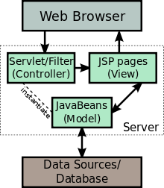

Figure 4.4.1- JSP Model 2-Architecture

4.5 HTML:
WebPages are written in HTML - a simple scripting language.
HTML is short for Hyper Text Markup Language.
- Hypertext is simply a piece of text that works as a link.
- Markup Language is a way of writing layout information within documents.
Basically an HTML document is a plain text file that contains text and nothing else. When a browser opens an HTML file, the browser will look for HTML codes in the text and use them to change the layout, insert images, or create links to other pages.
Since HTML documents are just text files they can be written in even the simplest text editor. A more popular choice is to use a special HTML editor - maybe even one that puts focus on the visual result rather than the codes - a so-called WYSIWYG editor ("What You See Is What You Get").
Some of the most popular HTML editors, such as FrontPage or Dreamweaver will let you create pages more or less as you write documents in Word or whatever text editor you're using. However, there are some very good reasons to create your own pages - or parts of them - by hand. It is possible to create WebPages without knowing anything about the HTML source behind the page. There are excellent editors on the market that will take care of the HTML parts. All you need to do is layout the page.

4.5.1 HTML TAGS:
- HTML tags are used to mark-up HTML elements.
- HTML tags are surrounded by the two characters < and > are called angle brackets, the first tag in a pair is the start tag and the second tag is the end tag.
- The text between the start and end tags is the element content.
- HTML tags are not case sensitive; <b> means the same as <B>.

4.6 JAVA SCRIPT:
JavaScript is a scripting language that will allow you to add real programming to your WebPages. You can create small application type processes with JavaScript, like a calculator or a primitive game of some sort.
However, there are more serious uses for JavaScript:
- Browser Detection:
Detecting the browser used by a visitor at your page. Depending on the browser, another page specifically designed for that browser can then be loaded.
- Cookies:
Storing information on the visitor's computer, then retrieving this information automatically next time the user visits your page. This technique is called "cookies".
- Control Browsers:
Opening pages in customized windows, where you specify if the browser's buttons, menu line, status line or whatever should be present.
- Validating Forms:
Validating inputs to fields before submitting a form.
An example would be validating the entered email address to see if it has an @ in it, since if not, it's not a valid address.

CHAPTER - 5
SYSTEM DESIGN

5.1 INTRODUCTION:
Systems design is the process or art of defining the architecture, components, modules, interfaces, and data for a system to satisfy specified requirements. One could see it as the application of systems theory to product development. There is some overlap and synergy with the disciplines of systems analysis, systems architecture and systems engineering.
5.1.1 3-TIER ARCHITECTURE WEB APPLICATION:
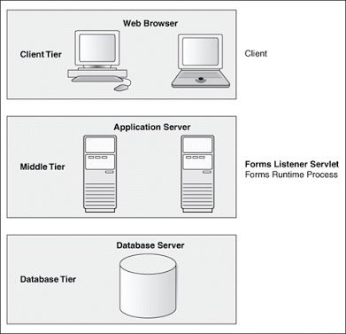

Figure 5.1.1.1 - 3-Tier Architecture

5.1.2 PHYSICAL CONTROL FLOW ARCHITECTURE:
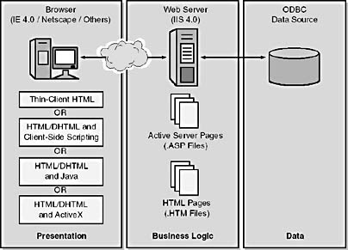

Figure 5.1.2.1 – Control Flow Architecture

5.2 MODULES:
The System consists of 2 Modules:
1 .Admin Module
2. Customer Login Module
5.2.1 ADMIN MODULE:
- Register New Customer
- Deposit Money
- List of Accounts
- Delete Account
5.2.2 CUSTOMER LOGIN MODULE:
- Login Account
- Transfer Money
- Withdraw Money
- Change Details
- Account Details

CHAPTER - 6
UML DIAGRAMS

6.1 UNIFIED MODELING LANGUAGE:

The Unified Modeling Language allows the software engineer to express an analysis model using the modeling notation that is governed by a set of syntactic, semantic and pragmatic rules.
A UML system is represented using five different views that describe the system from distinctly different perspective. Each view is defined by a set of diagram, which is as follows.

• User Model View:
- This view represents the system from the user’s perspective.
- The analysis representation describes a usage scenario from the end-users perspective.
• Structural model view:
- In this model the data and functionality are arrived from inside the system.
- This model view models the static structures.

• Behavioral Model View:
- It represents the dynamic behavioral as parts of the system, depicting the interactions of collection between various structural elements described in the user model and structural model view.

• Implementation Model View:
- In this the structural and behavioral as parts of the system are represented as they are to be built.

• Environmental Model View:
- In this the structural and behavioral aspects of the environment in which the system is to be implemented are represented.

6.2 UML DAIGRAMS:
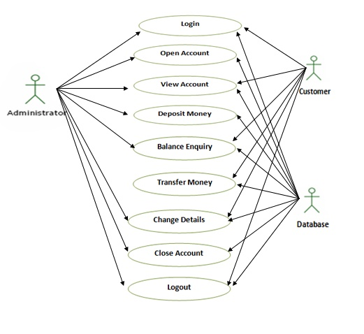
Figure 6.2.1 - Over All Use Case Diagram
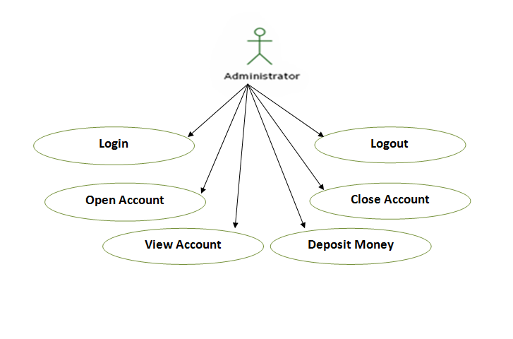
Figure 6.2.2 – Administrator Use Case Diagram

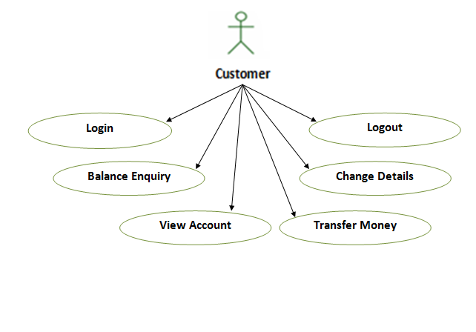

Figure 6.2.3 – Customer Use Case Diagram

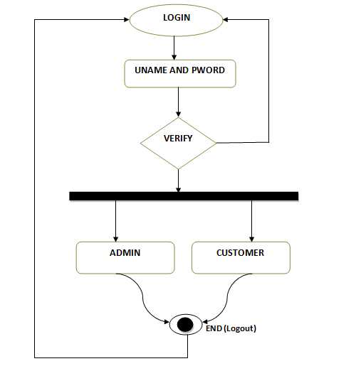

Figure 6.2.4 – Activity Diagram
Figure 6.2.5 – Class Diagram

Figure 6.2.6 - Sequence Diagram for Admin

Figure 6.2.7 - Sequence Diagram for Customer

CHAPTER-7
CODING
AND
IMPLEMENTATION

7.1 INTRODUCTION:
Coding and Implementation is the stage of the project when the theoretical design is turned out into a working system. Thus it can be considered to be the most critical stage in achieving a successful new system and in giving the user, confidence that the new system will work and be effective.
7.2 DATABASE CONNECTION:
In computer science, a database connection is the means by which a database server and its client software communicate with each other. The term is used whether or not the client and the server are on different machines.
The client uses a database connection to send commands to and receive replies from the server. A database is stored as a file or a set of files on magnetic disk or tape, optical disk, or some other secondary storage device. The information in these files may be broken down into records, each of which consists of one or more fields.
In our project we used MYSQL Database, is a relational database management system (RDBMS). In July 2013 it was the world’s second most widely used RDBMS, and the most widely used open-source RDBMS.
The following Program is used to connect with MYSQL Server:
package com.connect;
import java.sql.Connection;
import java.sql.DriverManager;
public class dbConnect
{
public static Connection getConnect()
{
try
{
Class.forName("com.mysql.jdbc.Driver").newInstance();
Connection
con=DriverManager.getConnection("jdbc:mysql://localhost:3306/bank1","root","system");
return con;
}catch(Exception e)
{
return null;
}
}
}
7.3 LOGIN PAGE :( login.java)
package com.bean;
import java.sql.*;
import com.connect.dbConnect;
public class login
{
private String username;
private String password;
public String getPassword() {
return password;
}

public String getUsername() {
return username;
}
public void setPassword(String password) {
this.password = password;
}
public void setUsername(String username) {
this.username = username;
}
public String validate()
{
try
{
Connection con=dbConnect.getConnect();
Statement st=con.createStatement();
ResultSet rs=st.executeQuery("select * from record where username='"+username+"' and password='"+password+"'")
if(rs.next())
{
return "home.jsp";
}
else
{
return "index.jsp";
}
}catch(Exception e)
{
return "error.jsp";
}
}
}
7.4 REGISTRATION :( reg.java)
package com.bean;
import java.sql.Connection;
import java.sql.ResultSet;
import java.sql.Statement;
import com.connect.dbConnect;
public class registerBean
{
private String username;
private String password;
private String amount;
private String address;
private String phone;
private String acct_no;
public void setAddress(String address) {
this.address = address;
}
public void setAmount(String amount) {
this.amount = amount;
}
public void setPassword(String password) {
this.password = password;
}
public void setPhone(String phone) {
this.phone = phone;
}
public void setUsername(String username) {
this.username = username;
}
public void setAcct_no(String acct_no) {
this.acct_no=acct_no;
}
public String getAddress() {
return address;
}
public String getAmount() {
return amount;
}
public String getPassword() {
return password;
}
public String getPhone() {
return phone;
}
public String getUsername() {
return username;
}
public String getAcct_no() {
return acct_no;
}
public String insert()
{
try{
Connection con=dbConnect.getConnect();
Statement st=con.createStatement();
ResultSet rs=st.executeQuery("select * from record where username='"+username+"'");
if(rs.next())
{
return "error";
}
int x=st.executeUpdate("insert into record values('"+username+"','"+password+"',"+amount+",'"+address+"','"+phone+"','"+acct_no+"')");
if(x>0) {
return "register";
}
else
return "error.jsp";
}catch(Exception e){
return "error.jsp";
}
}}
7.5 HOME PAGE(index.jsp):
<div id="container">
<%String name=(String)session.getAttribute("username");
session.setAttribute("contact_status","null");
%>
<link href="css.css" rel="stylesheet" type="text/css"/>
<jsp:include page="header.jsp"></jsp:include>
<div id="content-container">
<div id="content">
<marquee><h2 style="color: red;"><i>
<%
if(name==null)
{%>
- Welcome Guest -
<%}
else
{%>
- Welcome <%=name%> -
<%}%>
</i></h2></marquee><br/><br/>
<center><img src="images/index.jpg" width="550" height="250px"/></center>
</div>
<div id="aside">
<%
if(name==null)
{%>
<h2>Login :-</h2>
<jsp:include page="login.jsp"></jsp:include>
<%}
else
{%>
<p>* Online banking is the practice of making bank transactions or paying bills via the Internet.
<br/></br>* Banking online allows a customer to make deposits, withdrawals, transfers with the click of a mouse.
<br/><br/>* Online banking also eliminates paper waste, which is a plus not only for those who have to handle all the paper work, but also for the environment.</p> <%}%></div>
<div>
<marquee scrollamount="15" direction="up" behavior="alternate"><marquee scrollamount="15" direction="right" behavior="alternate"><img src="butterfly.gif" /></marquee></marquee>
</div>
</div>
<jsp:include page="footer.jsp"></jsp:include></div>
7.6 DATA DICTIONARY:
Column name | Data type | Nullable | Primary key
ACCOUNTINFO | Varchar2 | No | Yes
USERNAME | Varchar2 | No | No
PASSWORD | Varchar2 | No | No
AMOUNT | Int | No | No
ADDRESS | Varchar2 | No | No
PHONE | Varchar2 | No | No

Table 7.1 Database Table Specifications

CHAPTER-8
SCREENSHOTS

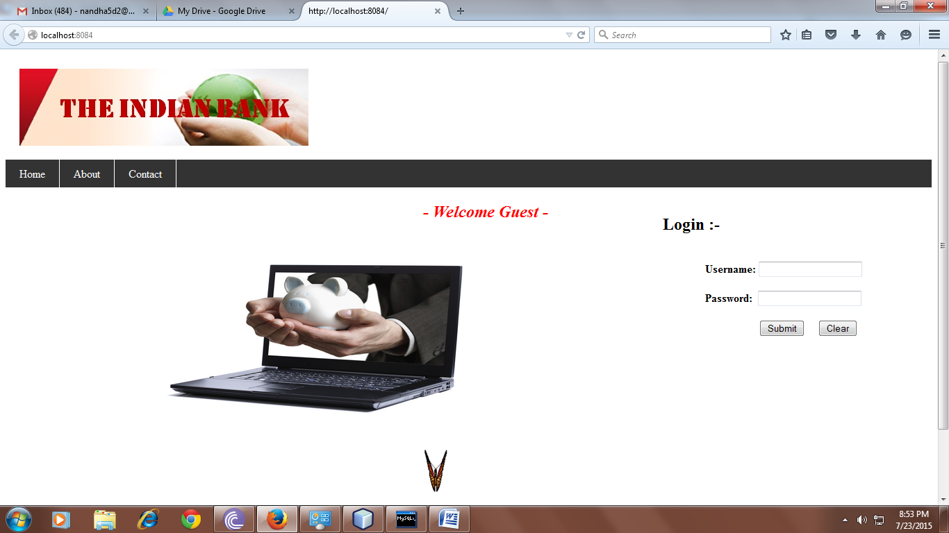
Screenshot 8.1 - Home page
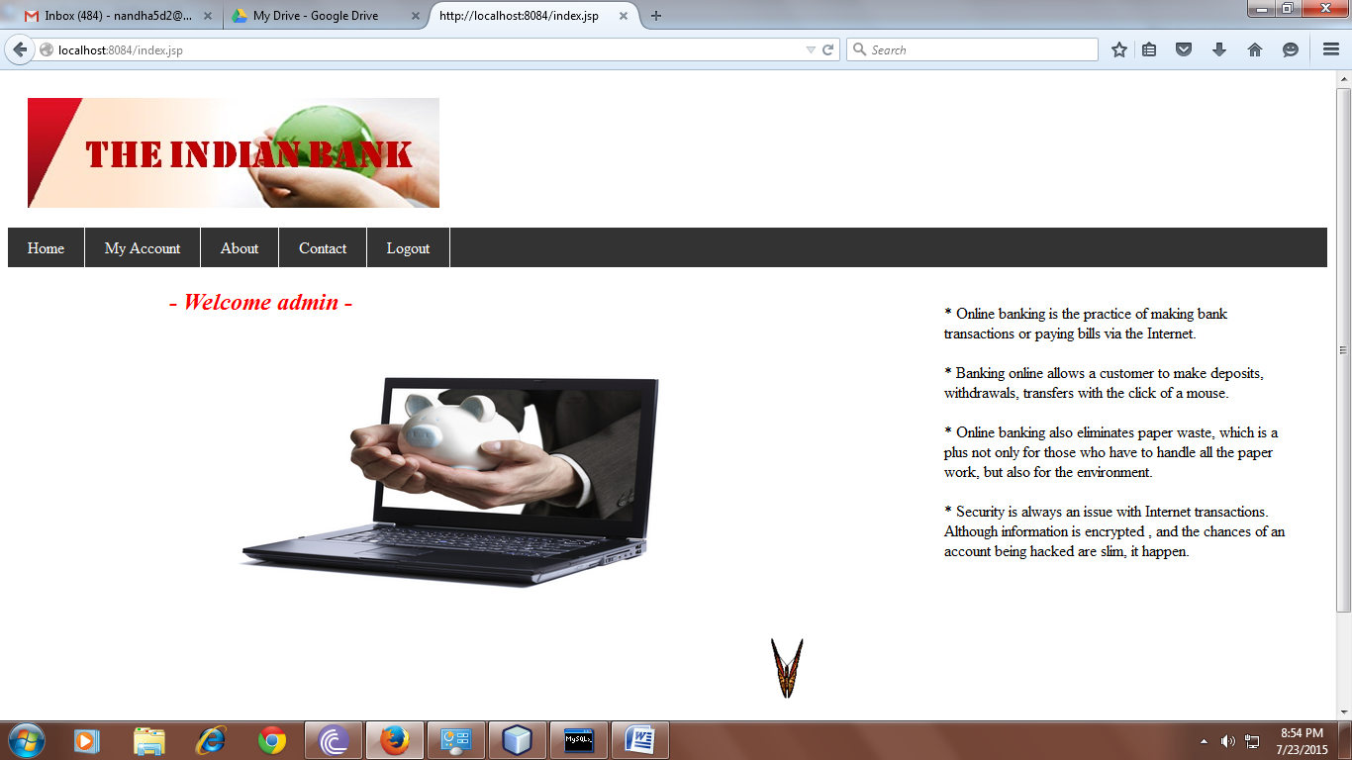

Screenshot 8.2 – Administration Login Page
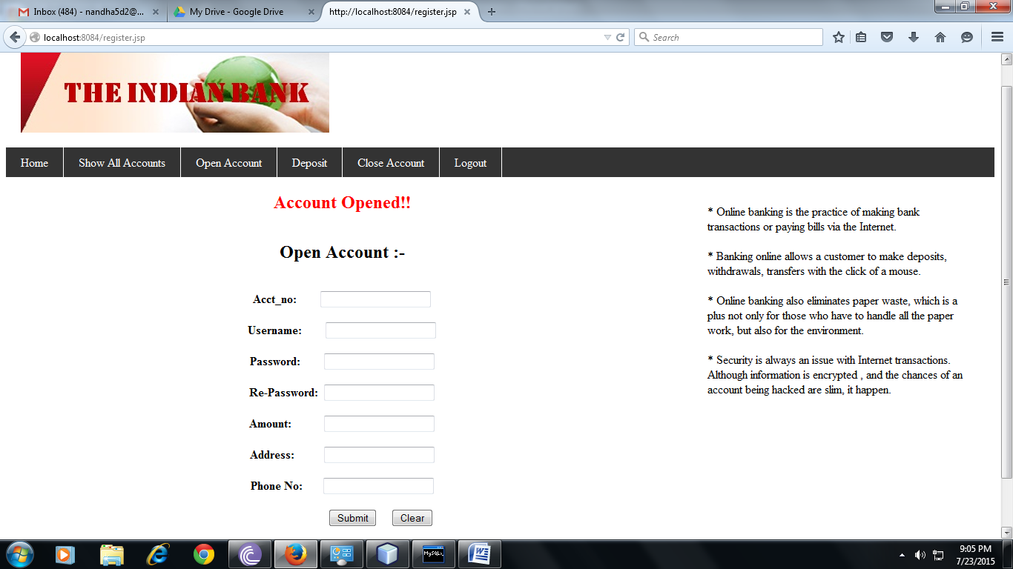
Screenshot 8.3 – Registration Page

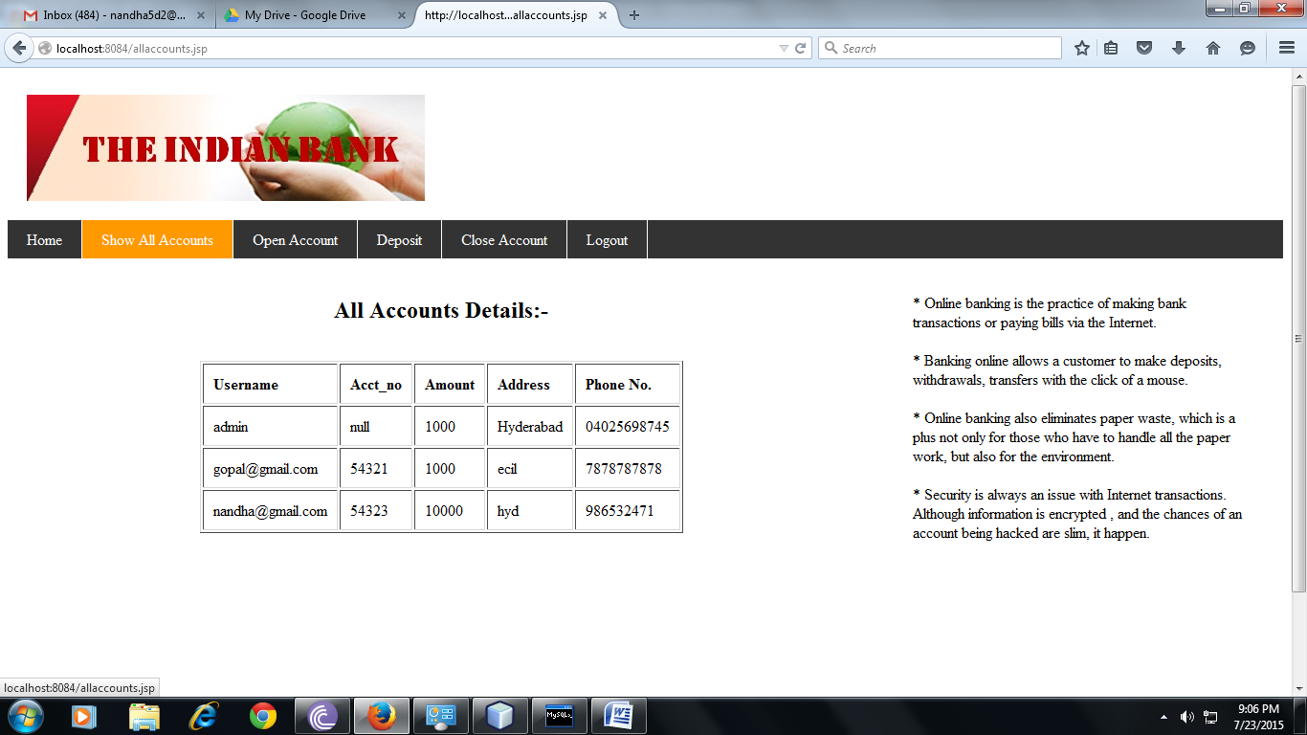
Screenshot 8.4 – List of Accounts Page

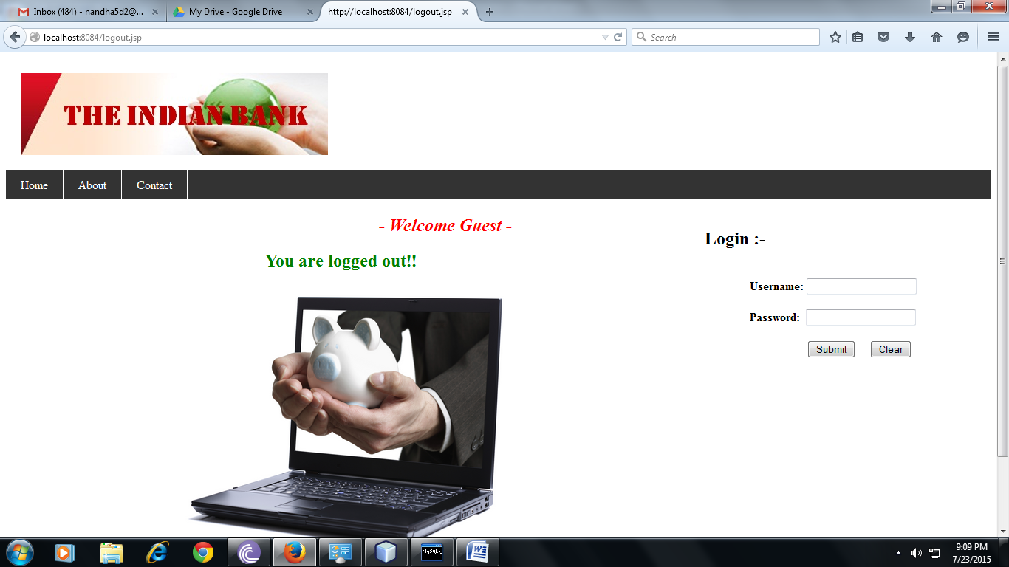
Screenshot 8.5 – Admin Logout page

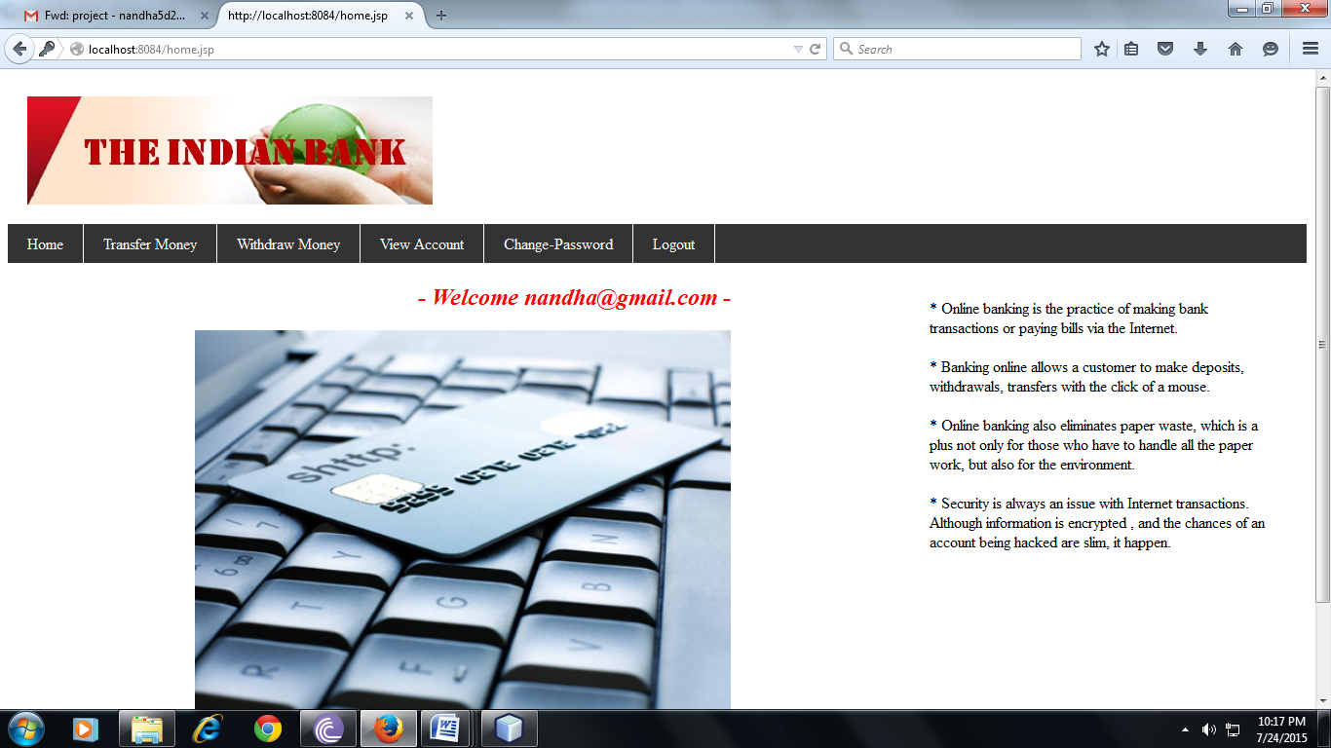
Screenshot 8.6 - Customer Login Page

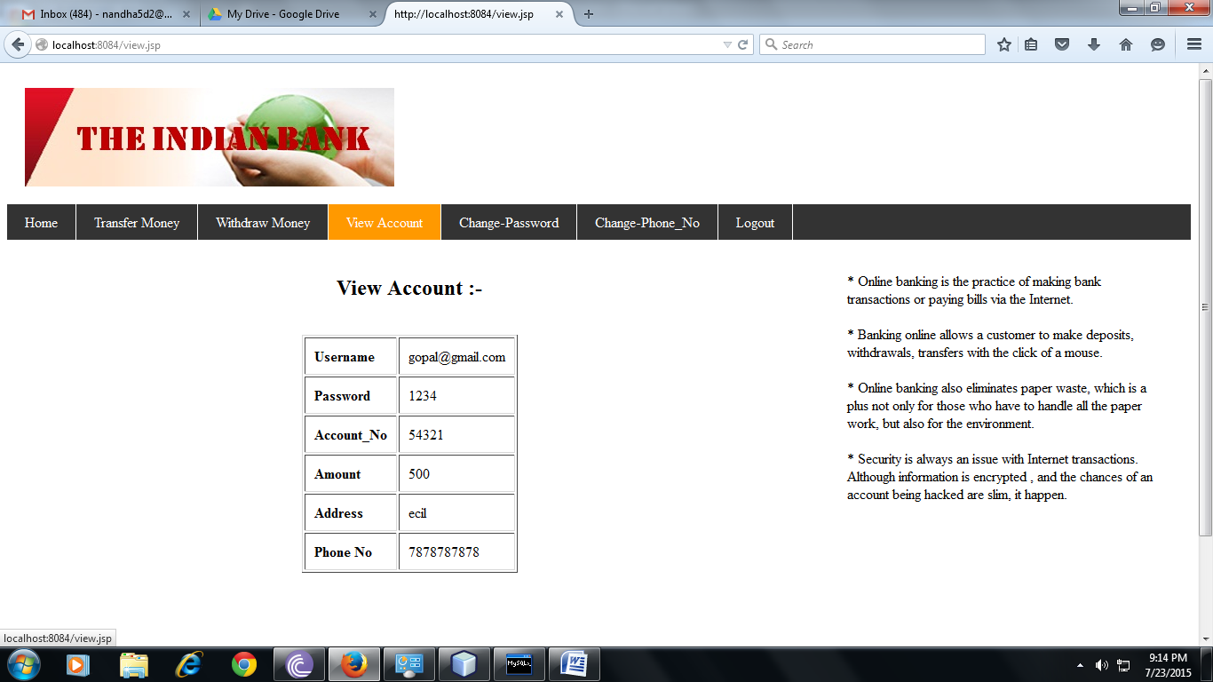
Screenshot 8.7 – Customer Account Details

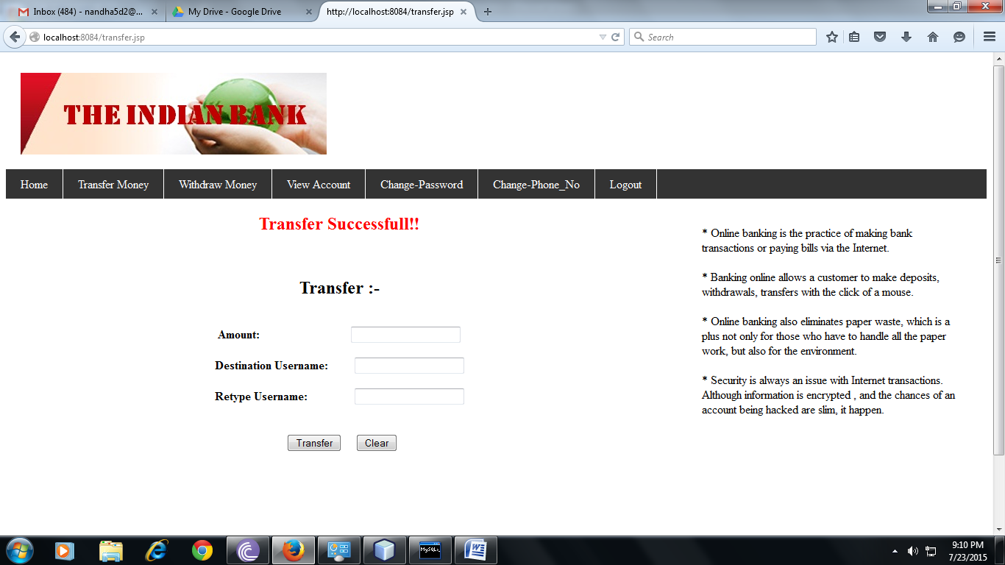
Screenshot 8.8 – Transfer Money

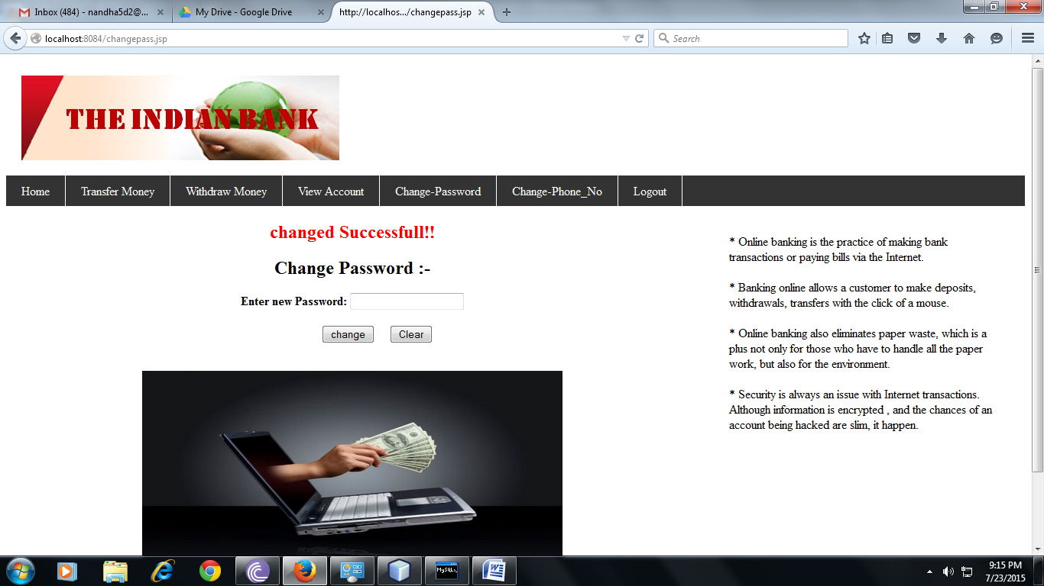
Screenshot 8.9 – Change Password Page

Screenshot 8.10 – Customer Logout page

CHAPTER-9
SYSTEM TESTING

9.1 INTRODUCTION TO TESTING:
Testing is a process, which reveals errors in the program. It is the major quality measure employed during software development. During software development. During testing, the program is executed with a set of test cases and the output of the program for the test cases is evaluated to determine if the program is performing as it is expected to perform.

9.2 TESTING STRATEGIES:
In order to make sure that the system does not have errors, the different levels of testing strategies that are applied at differing phases of software development are:
    - UNIT TESTING:
Unit Testing is done on individual modules as they are completed and become executable. It is confined only to the designer's requirements.
Each module can be tested using the following two Strategies:
      - BLACK BOX TESTING:
In this strategy some test cases are generated as input conditions that fully execute all functional requirements for the program. This testing has been uses to find errors in the following categories:
- Incorrect or missing functions.
- Interface errors.
- Errors in data structure or external database access.
- Performance errors.
- Initialization and termination errors.

In this testing only the output is checked for correctness. The logical flow of the data is not checked.

      - WHITE BOX TESTING:
In this the test cases are generated on the logic module by drawing flow graphs of that module and logical decisions are tested on all the cases. It has been uses to generate the test cases in the following cases:
- Guarantee that all independent paths have been executed.
- Execute all logical decisions on their true and false Sides.
- Execute all loops at their boundaries and within their operational bounds.
- Execute internal data structures to ensure their validity.

    - INTEGRATION TESTING:
Integration testing (sometimes called integration and testing, abbreviated I&T) is the phase in software testing in which individual software modules are combined and tested as a group. It occurs after unit testing and before validation testing. Integration testing takes as its input modules that have been unit tested, groups them in larger aggregates, applies tests defined in an integration test plan to those aggregates, and delivers as its output the integrated system ready for system testing.
    - SYSTEM TESTING:
System testing of software or hardware is testing conducted on a complete, integrated system to evaluate the system's compliance with its specified requirements. System testing falls within the scope of black box testing, and as such, should require no knowledge of the inner design of the code or logic.
As a rule, system testing takes, as its input, all of the "integrated" software components that have passed integration testing and also the software system itself integrated with any applicable hardware system(s). The purpose of integration testing is to detect any inconsistencies between the software units that are integrated together (called assemblages) or between any of the assemblages and the hardware. System testing is a more limited type of testing; it seeks to detect defects both within the "inter-assemblages" and also within the system as a whole.

  - TEST CASES:
Test Cases | Priority | Preconditions | Input Test Data | Steps to be Executed | Expected Results | Actual Results | Pass/Fail
1. Test if user is able to login successfully. | A | User must be registered already | correct username, correct password | 1) Enter input (correct) username and password on the respective fields.  2)click submit/login | User must successfully login to the web page | (note down the results you have observed) | Pass
2.Test if unregistered users is not able to login to the site | A |  | incorrect username, incorrect password | 1) Enter input (incorrect) username and password on the respective fields.  2)click submit/login | Proper error must be displayed and prompt to enter login again | (note down the results you have observed) | Pass
3.Test with valid username and empty password such that login must get failed | B | User must be registered already | valid username and empty password | 1)enter the valid username in the user id and enter no password in the password field | Proper error must be displayed and prompt to enter login again | (note down the results you have observed) | Pass
4.Test with empty username and valid password such that login must get failed | B | registered user's password | empty username and valid password | 1)leave the username empty in the user id and enter a valid user's password in the password field | Proper error must be displayed and prompt to enter login again | (note down the results you have observed) | Pass
5.Test with empty username and empty password and check if login fails | A | - | - | 1)Enter nothing in the mail id and password field 2)click submit button | Proper error must be displayed and prompt to enter login again |  | Pass
6.Check of the password is masked on the screen i.e., password must be in bullets or asterisks | B |  | some password(can be a registered/unregistered) | 1) Enter the password field with some characters | The password field should display the character in asterisks or bullets such that the password is not visible on the screen |  | Pass
7.Check if the login function handles case sensitivity | B | registered user's password which is originally in lower case changed to upper case or vice versa | case changed username /password | 1)Enter the case changed username /password in the respective field and 2)click login button | Login must fail saying incorrect username/password | - | Pass
8.After logging in try to copy/cut the password and paste it on another screen(passwords are usually in * such that its not visible on the screen) | B |  | Registered user's login id and password | 1)Enter username and password in the respective fields. Copy the password field's content(which is in *s) 3)paste the content on another screen | password shouldn’t get pasted / password should not be visible on the screen | - | Pass
9.Verify account lock | B |  | Registered user's login id and incorrect password | 1)Try to login with a registered user name and incorrect password for more than 3 times | Account should be locked and access should be granted only after getting certain assurance from the user | - | Fail
10.Check if on selecting back button (after logging out) if the user is not signed in | B |  | Registered username and password | 1)Login with registered username and password 2)once your are logged in, sign out of the site 3)now press back button | User shouldn’t be signed in to his account rather a general webpage must be visible | - | Pass
11.Verify the url without logging into to the site | B |  | Registered username and password | 1) Login to the site using registered username and password 2)copy and save the url of the logged in page 3)logout of the site 4)now paste the copied url on the browser | the url should not redirect to a logged in page but to a logged out page of the site | - | Pass
12.Automatic logout of the site when pressing backspace button | B | User must be registered already | Registered username and password | 1) Login to the site using registered username and password 2)now press backspace | User must logout of the site properly | - | Pass
Table 9.3.1 Test Cases for Login Page

CHAPTER-10
PROJECT SUMMARY

10.1 CONCLUSION:
This project developed, incorporated all the activities involved in the browsing centre.
It provides all necessary information to the management as well as the customer with the use of this system; the user can simply sit in front of the system and monitor all the activities without any physical movement of the file. Management can service the customer’s request best in time.
The system provides quickly and valuable information. These modules have been integrated for effective use of the management for future forecasting and for the current need.
10.2 LIMITATIONS:
- Requires a server that needs to be online every time.
- Application is used for accounts of the same bank/Group only.
- Transactions are limited and transactions like DD’s, Loans etc are not handled.
10.3 SCOPE FOR FURTHER DEVELOPMENT:
Internet banking or online banking is "still in a strong growth phase," according to a report on retail Internet banking by Celent Communications (Boston). About one-third of households have active online Internet banking users, Celent estimates. That should approach 50 percent by the end of the decade, driven by broadband penetration and the further maturity of Web-based services, the report predicts.
The system can be designed for further enhancement .This could also be developed according to the growing needs of the customer.

CHAPTER-11
BIBLIOGRAPHY
- FOR JAVA INSTALLATION:
    - https://www.java.com/en/download/
- FOR ORACLE DATABASE INSTALLATION:
    - http://www.oracle.com/index.html
- REFERENCE WEBSITES:
    - https://en.wikipedia.org/wiki/Main_Page
    - www.w3schools.com
    - http://www.tutorialspoint.com/java/index.htm
- REFERENCE BOOKS:
- Raghu Ramakrishnan Database Management System, Johannes Gehrke, 2000 - Mc Graw-Hil International Edition.
- Roger S.Pressman, 1997 - Software Engineering, Fourth Edition, Mc Graw-Hill International Edition.
- Herbert Schildt, 2011 - The Complete Reference Java, Mc Graw-Hill International Edition.
- A.A.Puntambekar, 2015 - Web Technologies, Technical Publications.

